SIMATS ENGINEERING

ASSESSMENT TOOL 2

COURSE NAME: Deep Learning COURSE CODE: MLA0408

COURSE OUTCOME COVERED

CO1: Learning Algorithms, Maximum Likelihood Estimation (MLE), Building Machine Learning Algorithms, Neural Networks, Artificial Neurons, Perceptron, Multilayer Perceptron (MLP), Forward Propagation, Backpropagation Algorithm, Gradient Descent, Stochastic Gradient Descent (SGD), Mini-Batch Gradient Descent, Curse of Dimensionality. (BL3)

Duration: 1 Hour
QUESTIONS: 1 Total Marks:50

Annexure A

Error Analysis Task

- A neural network predicts student scores with an MSE of 0.85 during training and 5.20 during testing. Analyse the possible reasons for this difference and suggest suitable corrective measures.

Code of Conduct:

I vemu;a saiteja,192425083 (Name / Reg No) certify that this submission is my original work and that I have adhered to the guidelines specified for this assessment.
I understand that any violation of academic integrity rules will result in disciplinary action.

Signature of the student:

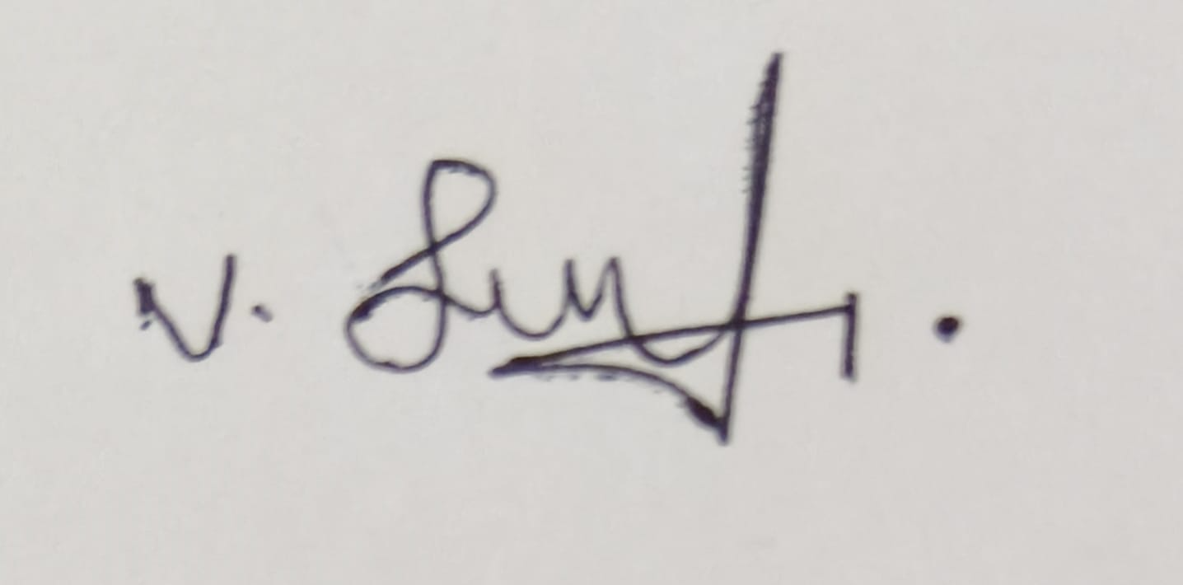

RUBRICS FOR CALCULATION

Criteria | Weightage | Level 4 – Exemplary (5) | Level 3 – Proficient (4) | Level 2 – Developing (2-3) | Level 1 – Beginning (0-1)
Error Identification | 30% | Correctly identifies all errors and their causes | Identifies most errors with minor omissions | Identifies some errors but misses key issues | Unable to identify errors
Error Analysis & Reasoning | 30% | Provides clear and logical explanation of why errors occurred | Reasoning mostly corrects with minor gaps | Limited reasoning and partial explanation | No meaningful analysis
Correction Strategy | 25% | Suggests appropriate corrections with justification | Suggests correct corrections with minor gaps | Partially correct corrections | Incorrect or no corrections
Interpretation of Results | 15% | Clearly explains impact of errors on model performance/results | Basic interpretation with minor omissions | Limited interpretation | No interpretation provided

1. Understanding the Results:
The Mean Squared Error (MSE) measures the average squared difference between the predicted and actual values.
- Training MSE = 0.85: The model predicts the training data with very small errors.
- Testing MSE = 5.20: The prediction error on unseen data is much larger.
Since the testing error is significantly higher than the training error, the model is not generalizing well. This is a strong indication of overfitting, where the neural network has learned the training data too closely instead of learning general patterns.

2. Analysis of the Difference
Criterion | Analysis
Training Performance | The low training MSE (0.85) shows that the model has learned the training dataset effectively and produces accurate predictions on known data.
Testing Performance | The high testing MSE (5.20) indicates poor performance on new or unseen data, meaning the model cannot generalize well.
Performance Gap | The difference between 0.85 and 5.20 is 4.35, which is large. A large gap between training and testing errors is a classic sign of overfitting.
Generalization Ability | The neural network has low generalization ability because it performs well only on the training dataset but not on the testing dataset.

3. Possible Reasons for High Testing Error

A. Overfitting
- The neural network has memorized the training data instead of learning meaningful relationships.
- It captures noise and small variations that do not exist in new data.
- This is the most likely reason because the training error is very low while the testing error is much higher.

B. Model is Too Complex
- The network may contain many hidden layers or a large number of neurons.
- A complex model has high capacity and may fit every detail of the training data, including noise.

C. Insufficient Training Data
- If the dataset is small, the model has fewer examples from which to learn.
- Limited data reduces the model's ability to recognize general patterns.

D. Noisy or Poor-Quality Data
- The training data may contain incorrect labels, missing values, or outliers.
- The model may learn these incorrect patterns, reducing performance on new data.

E. Lack of Regularization
- Regularization techniques help prevent overfitting.
- Without them, the model's weights may become too large, causing poor generalization.

F. Improper Data Split
- If the training and testing datasets come from different distributions, the model will struggle to perform well on the testing data.

G. Excessive Training (Too Many Epochs)
- Training for too many epochs allows the model to continue reducing training error while increasing testing error.
- This leads to overfitting.

4. Corrective Measures:

Problem | Corrective Measure | Explanation
Overfitting | Early Stopping | Stop training when the validation error starts increasing to prevent memorization.
Model Complexity | Reduce Hidden Layers or Neurons | A simpler model is less likely to memorize the training data.
Lack of Regularization | Apply L1 or L2 Regularization | Penalizes large weights and encourages simpler models.
Overfitting | Dropout Technique | Randomly deactivates neurons during training, forcing the network to learn robust features.
Small Dataset | Increase Training Data | More examples improve the model's ability to generalize.
Poor Data Quality | Data Cleaning | Remove outliers, correct errors, and handle missing values.
Poor Generalization | Cross-Validation | Evaluates the model on different subsets of data to improve reliability.
Feature Issues | Feature Selection/Normalization | Remove irrelevant features and scale input data for better learning.

5. Conclusion :
The neural network shows excellent performance on the training dataset (MSE = 0.85) but poor performance on the testing dataset (MSE = 5.20). The large difference of 4.35 indicates overfitting, meaning the model has memorized the training data rather than learning patterns that generalize to unseen data. To improve testing performance, techniques such as early stopping, dropout, L1/L2 regularization, cross-validation, increasing the training dataset, simplifying the network architecture, and cleaning the data should be applied.

